**Single-Cycle RISC-V CPU**

**Based on the image**

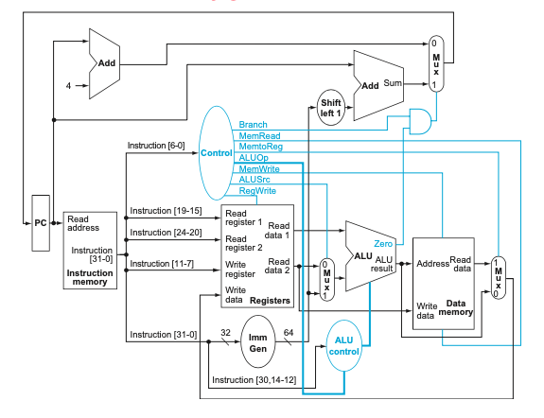

**>>>>>>>>>>>>>>>>>>>>**

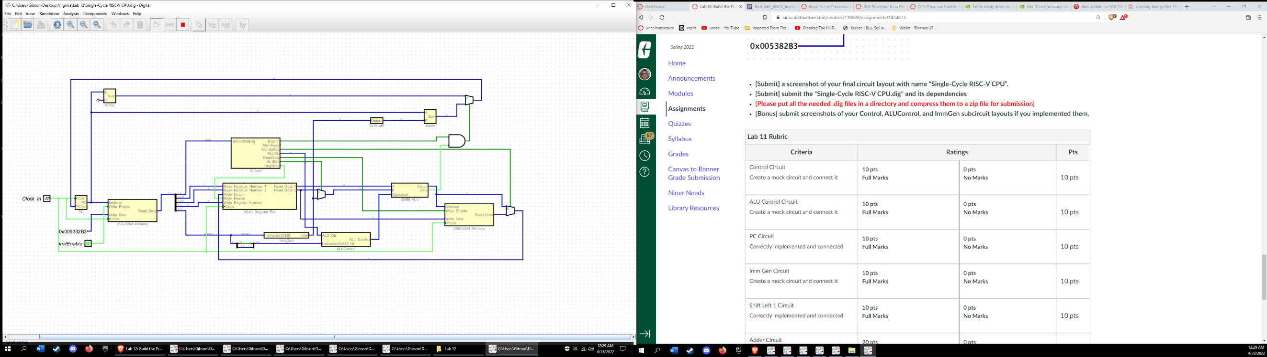*Control, ALUControl, and ImmGen subcircuits implemented